

Advanced Algorithms & Advanced Programming

TSN Project Report

Skander Kechaou
Har Aziz Singh
Kacper Janus

Table of Contents

10

I. Generalities 2
II. Needs analysis specifications 6
1. Actors identification & user stories 6
2. Functional specifications 10
III. Design and architecture 12
1. Introduction 12
2. Logical Architecture 11
3. Class Diagram 16
IV. Project Presentation 14
1. Application Development 14
2. Scenarios 19

GitHub Repository: https://github.com/kjanus03/tsn.git
- Generalities
- Project Overview
  - Purpose:
The project aims to design and develop a TSN (Tailored Social Network) platform that offers advanced functionalities beyond traditional platforms like Facebook. The platform is based on a graph structure, inspired by the FOAF (Friend of a Friend) Ontology enabling users to connect, interact, and share content in a more personalized and intuitive manner.
  - Objectives:
- Design a Graph-Based User Connection Model
To implement a graph data structure inspired by FOAF ontology, enabling efficient representation of user relationships, mutual connections, and interests.
- Develop Intelligent Content and Friend Recommendations
To build recommendation algorithms that suggest connections, or content based on user behavior, preferences, and interaction history.
- Ensure User-Centric Privacy and Customization
To provide post privacy controls and customizable profiles that allow users to manage their personal data, content visibility, and interface experience.
  - Scope of the Project:
The platform will include the following functionalities:
- Graph-Based Networking
- Recommendation System
- Privacy Controls
- Customizable User Profiles
- Intuitive User Interface:
- Messaging and Notifications
- Content Sharing and Collaboration

- Tools and Technologies Used
Layer | Technology
Backend Framework | Flask (Python)
Database | PostgreSQL  (via SQLAlchemy + psycopg2)
ORM and Migrations | SQLAlchemy + Flask-Migrate + Alembic
Auth and Security | Flask-Login, Flask-Security(-Too), bcrypt, argon2
Forms and Templates | WTForms, Flask-WTF, Jinja2
Real-Time | Flask-SocketIO
OAuth | Flask-Dance
Generating Data | Faker
Utilities | dotenv, bleach, webencodings
- Expected Outcome
The successful implementation of this platform will:
- A Fully Functional Graph-Based Social Network System
A working web platform where users can register, connect with others, and interact through a personalized network built on a graph data model inspired by FOAF ontology.
- Enhanced User Engagement Through Smart Features
Intelligent recommendation algorithms for suggesting friends or content based on user interactions and preferences, along with real-time messaging and notifications to increase user engagement.
- Customizable and Secure User Experience
Rich, multimedia-supported profiles, privacy settings, and secure authentication mechanisms to provide a safe and personalized user environment.
- Scalable and Modular System Architecture
A clean separation of concerns between backend services, database management, and frontend presentation, following best practices in modular design to support scalability and future feature expansion.
- Robust Testing and Deployment Readiness
A well-tested application with core functionalities verified through real use-case scenarios, supported by seed data, allowing for smooth deployment in a real-world environment or further academic iteration.

- Methodology Selection
Choosing the right methodology ensures that the project is completed efficiently.
Agile methodology was chosen for various reasons:
- Iterative Development: The project is broken into smaller increments aka sprints, each delivering a functional part of the system.
- Flexibility: Agile relies on iterative cycles, allowing teams to adapt to changes and regularly refine their work (Wrike, n.d.).
- Continuous Feedback: Involves the supervisor’s feedback regularly to ensure the development aligns with the expectations.
Scrum is the specific framework chosen since our project has rapidly-changing requirements and in this case allowing for:
- Sprint planning (using short sprints)
- Daily meetings
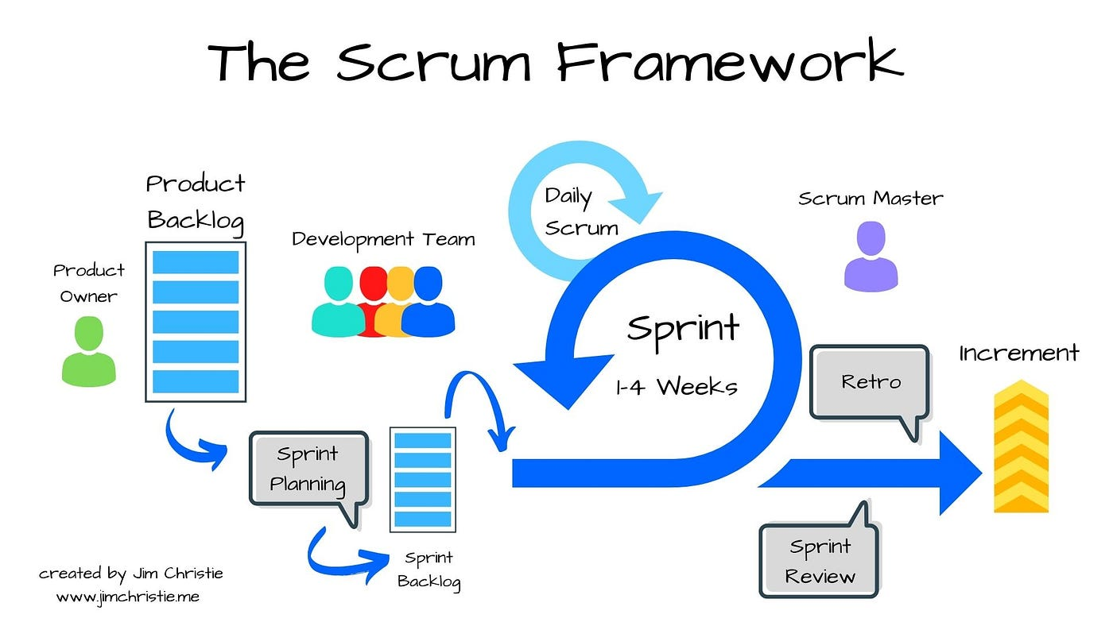
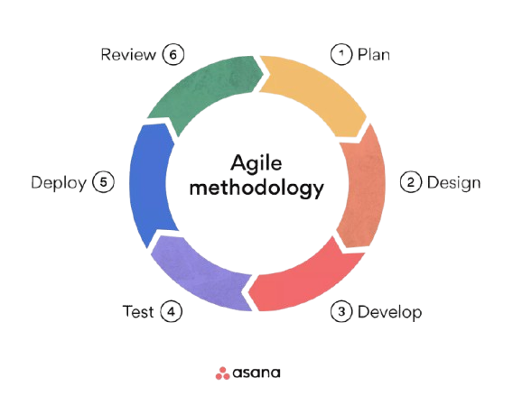
- Incremented deliverables
Figure 4 - Agile Methodology
Figure 5 - Scrum Framework

- Needs analysis specifications

1. Actors identification & user stories

The identified actors are necessary for the implementation of the system:
- Guest - Unauthenticated user
- User - Authenticated regular user
- Admin - System administrator with elevated privileges
- Event Creator - User who creates and manages events
- Event Participant - User who RSVPs to events

ID | User Story | Task ID | Task | Complexity
US001 | As a guest, I want to register an account so that I can access the system | T001 | Implement user registration | Medium
US002 | As a user / admin, I want to log in to my account so that I can access my profile | T002 | Implement secure login (email or google) and logout | Low
US003 | As a user, I want to update my profile information so that others can see my details | T003.1 | Create profile edit form with added details such as biography, location and profile picture | Low
 |  | T003.2 | Create upload_media and save_media functionalities for profile_pic | Medium
US004 | As a user, I want to reset my password | T004 | Implement password reset functionality with email service | Medium
US005 | As a user, I want to view posts, users and friends | T005 | Implement routes for each viewing with search queries and specific filters | Low
US006 | As a user, I want to create / edit / delete a post | T006.1 | Implement post CRUD | Medium
 |  | T006.2 | Add post visibility and media upload | Medium
US007 | As a user, I want to like or unlike, comment and share a post | T007.1 | Create a Like class with dynamic relationships to user and post as well fluid UI | Medium
 |  | T007.2 | Create a Comment class with dynamic relationships to post and user as well as fluid UI | Medium
 |  | T007.3 | Create a Share class with dynamic relationships to post and user as well as fluid UI | Medium
US008 | As a user, I want to add or remove friends from the list of active users | T008 | Create a friendship relationship with corresponding methods and UI | Medium
US009 | As a user, I want to view my posts, comments and shares as well statistics | T009.1 | Update the profile picture with a dynamic tabular view of self posts, comments and shares | Medium
 |  | T009.2 | Update the profile picture with statistics populated with advanced numerical methods (# friends, # posts…etc) | Low
US010 | As a user, I want to create / edit events so that I can organize activities | T010 | Implement event creation and editing with title, description, datetime, location | Medium
US011 | As an user, I want to view upcoming events | T011 | Create event listings view | Low
US012 | As a user, I want to RSVP to upcoming events | T012 | Implement RSVP functionality with SMS notifications | Medium
US013 | As an event creator, I want to add collaborators so that they can help me manage | T013 | Implement event collaborator addition functionality | Medium
US014 | As a user, I want to chat with my friends | T014 | Implement a messaging inbox with sockets and message class to store conversations and a fluid UI | Hard
US015 | As a user, I want to receive notifications of likes, comments, shares and messages | T015 | Implement a notification.js class and trigger a notification in like, comment, share classes and integrate with a fluid UI | Hard
US016 | As a user, I want to have a recommendation system for posts and friends | T016.1 | Implement a most popular posts recommendation system by giving weights to likes | Medium
 |  | T016.2 | Implement suggestion of friends of friends | Medium
US017 | As an admin, I want to login and access the admin dashboard | T017.1 | Add condition in log in for admins to access the admin dashboard | Low
US018 | As an admin, I want to manage users by deactivating / activating their accounts | T018 | Implement an activation / deactivation functionality | Low
US019 | As an admin, I want to view statistics and charts on the usage | T019.1 | Compute statistics with advanced numerical methods | Low
 |  | T019.2 | Create and display js charts displaying important information about social usage | Hard

3. Functional specifications
  - Functional specifications:
- User Registration and Authentication
  - Secure sign-up and login using hashed passwords.
  - Email validation and session/token-based authentication.
  - OAuth-based social login support.
- Graph-Based Friend Network
  - Represent user relationships as a graph.
  - Ability to add and remove friends.
- Profile Management
  - View and edit personal profiles (name, bio, image, etc.).
  - View personal posts, comments, shares and statistics.
- Content Sharing and Feed System
  - Users can create and share text/image/video posts.
  - View posts from friends in a personalized feed.
  - Like, comment, and interact with shared content.
- Event Creation and Collaboration
  - Users can create events.
  - Event creators can invite collaborators to manage events
  - Users can RSVP and receive SMS notifications
- Real-Time Messaging and Notifications
  - One-to-one chat feature using Flask-SocketIO.
  - Instant notifications for messages.
- Recommendation System
  - Suggest friends based on common connections or shared interests.
  - Recommend content or events based on user activity and profile similarity.
- Database Initialization and Seeding
  - Populate initial user and post data using Faker and seed scripts (populate_db.py).
  - Migrations handled using Flask-Migrate and Alembic.
- Security Features
  - CSRF protection via Flask-WTF.
  - Fine-grained access control using Flask-Security and Flask-Principal.

- Design and architecture

1. Introduction
The design and architecture phase translates the functional and non-functional specifications into a structured technical solution. This includes defining the logical components of the system, their interactions, and the core data structures. The objective is to establish a robust, scalable, and maintainable architecture to meet business goals.

2. Logical Architecture

2.1. Overview

The system is organized into three primary layers (MVC):
    - Frontend Layer:
- Technology: HTML, CSS, JavaScript, Jinja2
- Purpose:
  - Provides an intuitive user interface for registration, login, posting, messaging, and managing profiles.
  - Displays dynamic data rendered from the backend using Jinja2 templates.
- Interactions:
  - Sends requests to backend APIs and receives responses.
  - Uses WebSocket for real-time messaging.
    - Backend Layer:
- Technology: Flask (Python) and its libraries such as Flask-SocketIO, Flask-Security, Flask-Login.
- Purpose:
  - Handles user authentication, authorization, session management.
  - Implements business logic: friend connections, feed generation, recommendations.
  - Defines RESTful API endpoints and WebSocket routes.
- Components:
  - Routes (Controllers) : Handle route logic (e.g., user registration, sending messages).
  - Services: Contain reusable logic (e.g., graph traversal for friend suggestion).
  - WebSocket Handlers: For real-time communication (messaging, notifications).
    - Database Layer:
- Technology: PostgreSQL via SQLAlchemy ORM
- Purpose:
  - Stores all persistent data including users, posts, friend connections (edges), messages.
  - Maintains relational integrity and supports migrations using Alembic.
- Components:
  - Models for User, Post, Comment, Friendship, Message, etc.
  - Seeders (using Faker) and migration scripts for schema evolution.

2.2. Logical Components
- Authentication Module
  - Handles user registration, login, logout, and session/token management.
  - Manages OAuth login via Flask-Dance (Google).
  - Encrypts passwords using Argon2 or Bcrypt.
- User Profile Module
  - Manages user data (bio, profile picture, interests).
  - Allows users to update and view their profiles.
- Graph Manager
  - Models the friend relationships as a graph structure.
  - Implements logic for friend requests, acceptance, and traversal.
  - Supports mutual friend detection and second-degree connections.
- Recommendation Engine
  - Suggests new friends based on shared interests or graph proximity.
  - Recommends content based on interaction history and preferences.
- Feed Manager
  - Generates a dynamic feed of posts from friends and suggested users.
  - Prioritizes content based on recency, relevance, and engagement.
- Content Sharing Module
  - Allows users to create, edit, and delete posts (text/images/videos).
  - Enables likes, comments, and interactions on posts.
- Event Module
  - Create events and add collaborators
- Messaging Service
  - Enables one-to-one real-time chat using Flask-SocketIO.
  - Notifies users of new messages.

2.3. Data Flow
- Frontend Requests:

Users interact with the interface to send requests (e.g., create a new employee or assign a project).
- Backend Processing:

The backend validates and processes these requests, applying business logic.
- Database Transactions:

The backend interacts with the database to retrieve or modify data.

- Class Diagram
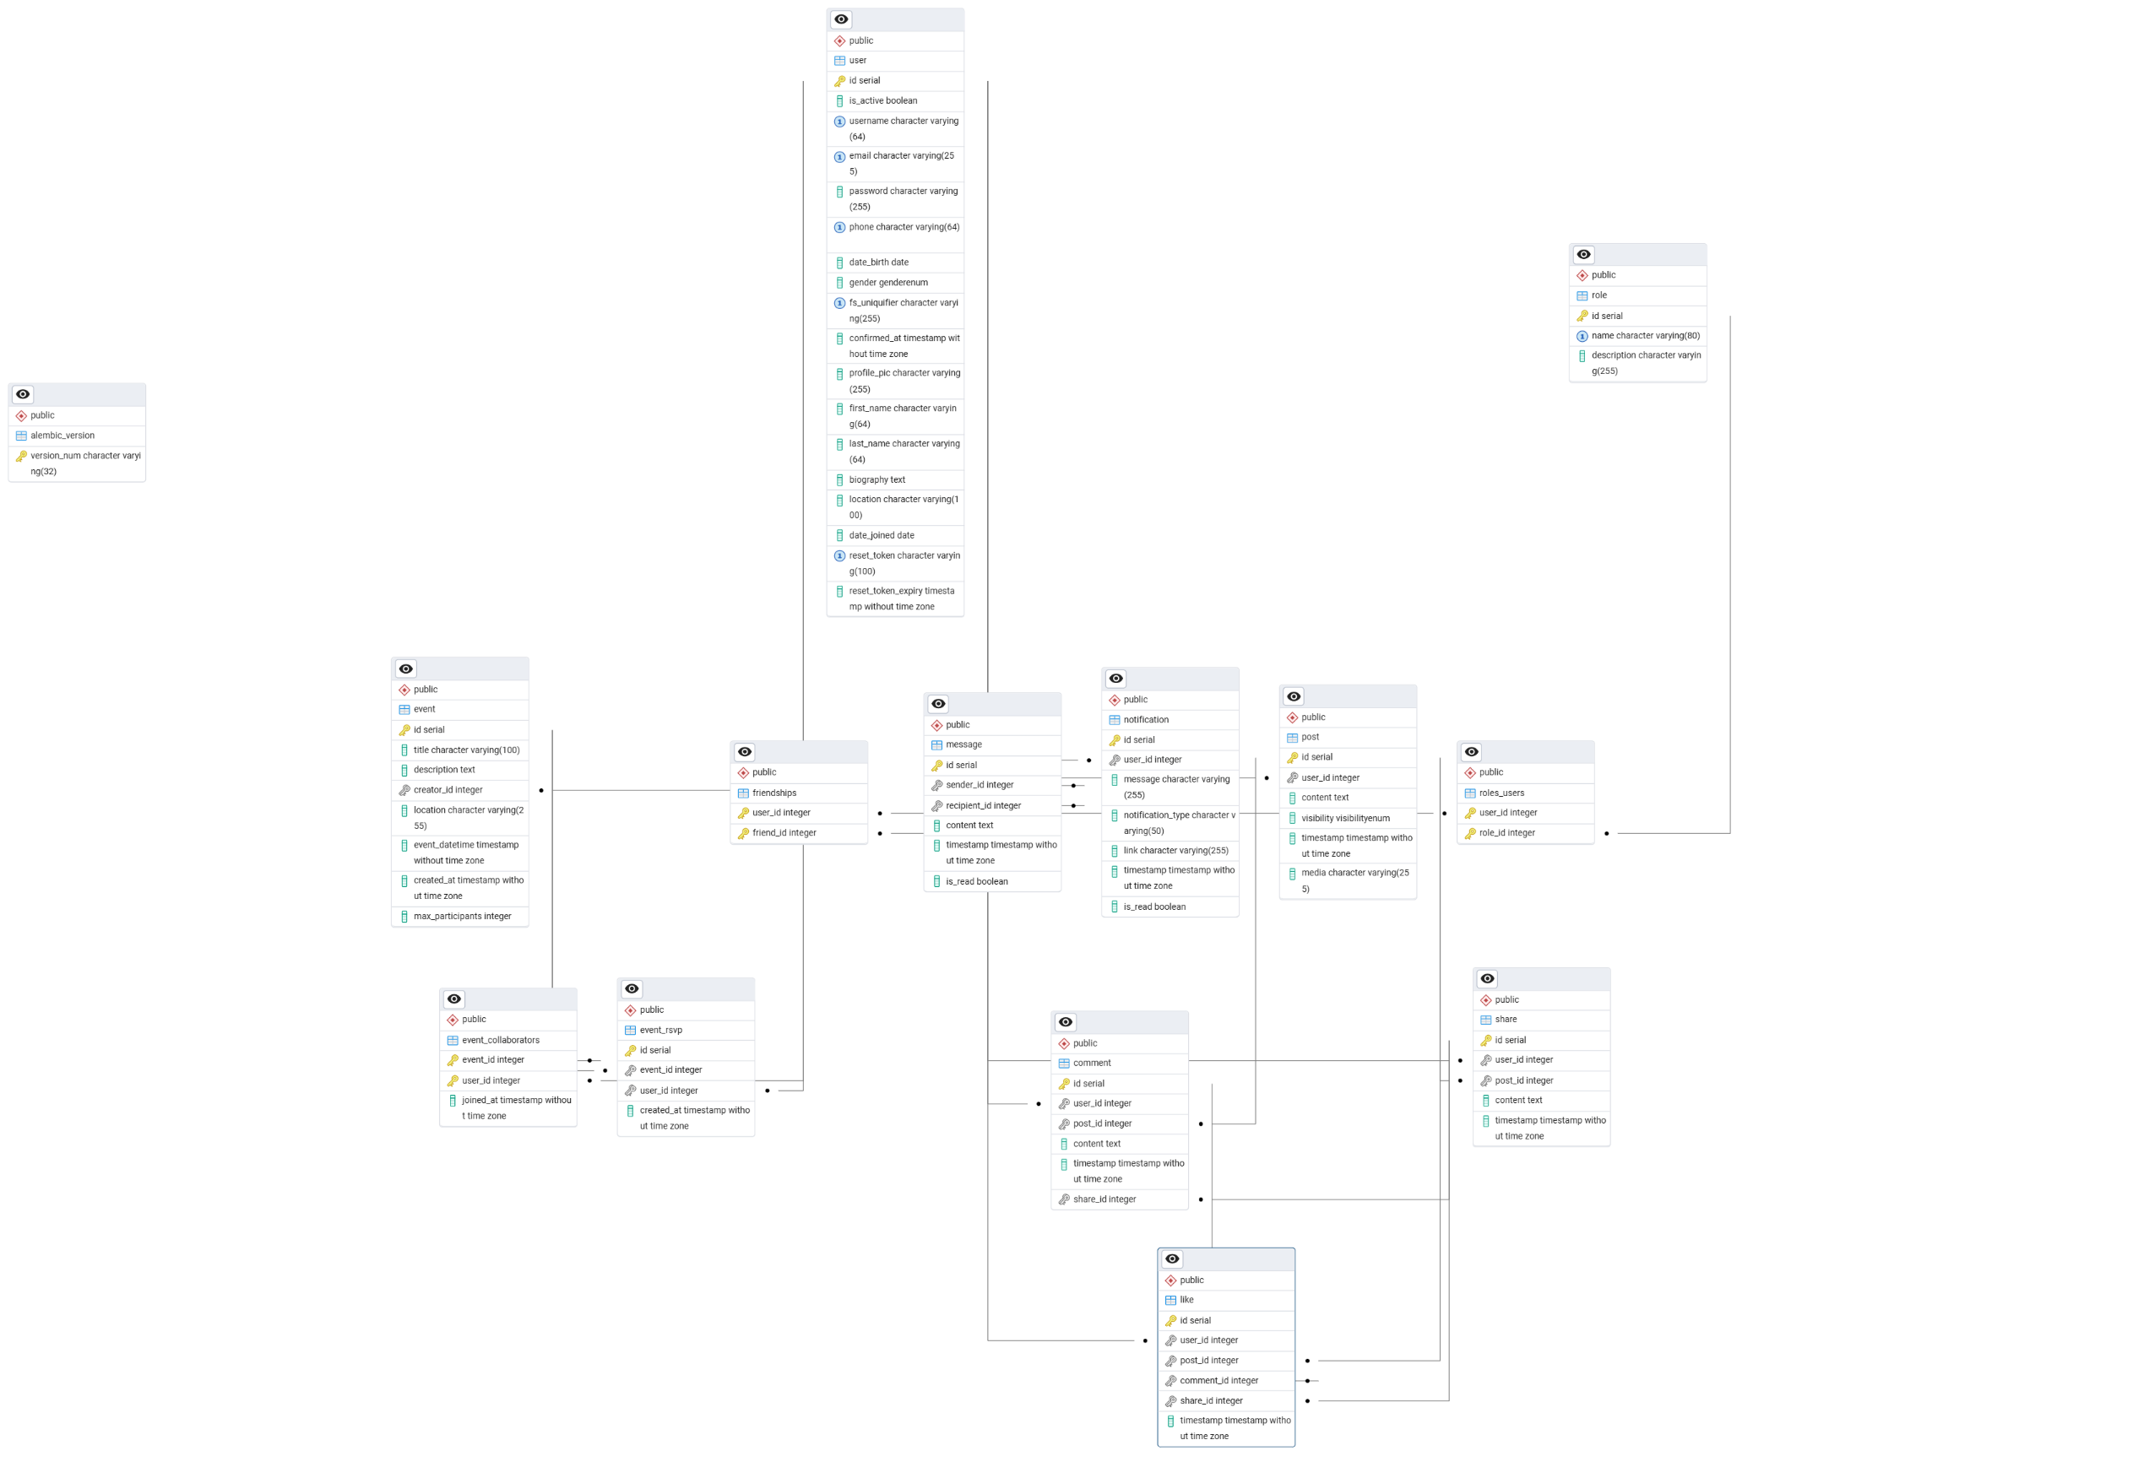
The class diagram illustrates the data structure and relationships between various entities within the system.
- Project Presentation

1. Application Development
This section provides an overview of the various services that form the backbone of the application, detailing their roles, functionality, and the technologies used in their implementation.

1.1 Backend Service

The backend service serves as the core of the application, handling all server-side logic and database interactions. It is built using Node.js with Express.js and follows a modular architecture for scalability and maintainability.
    - Key Components:
      - Models: Define the structure of the database entities facilitating database interactions.
      - Routes: Define the API endpoints and map them to specific methods for seamless communication with the frontend.
      - Migrations: Handle database schema evolution using version-controlled scripts to ensure consistency.
      - Exposes port 5000 on our local machine (localhost)

1.2 Data Enrichment Service (populate_db.py)
    - Key Components:
  - Uses Faker library to generate realistic test data (users, posts, friendships).
  - Scripts automate database seeding for development and testing environments.

1.3 Database Service
    - Features:
  - PostgreSQL server runs on port 5432.
  - Supports concurrent connections from backend and enrichment services.
  - Manages schema via Alembic migrations.

1.4 Frontend Service
    - Features:
      - Renders dynamic pages with Jinja2 templates.
      - Uses WebSocket for real-time messaging features.
      - Includes forms for registration, login, posting, and profile editing

  - Scenarios

Scenario 1: User Registration & Login
- New user registers via the signup page.
- Backend hashes password and stores user data.
- User logs in, session is created.
- OAuth login via Google as alternative.
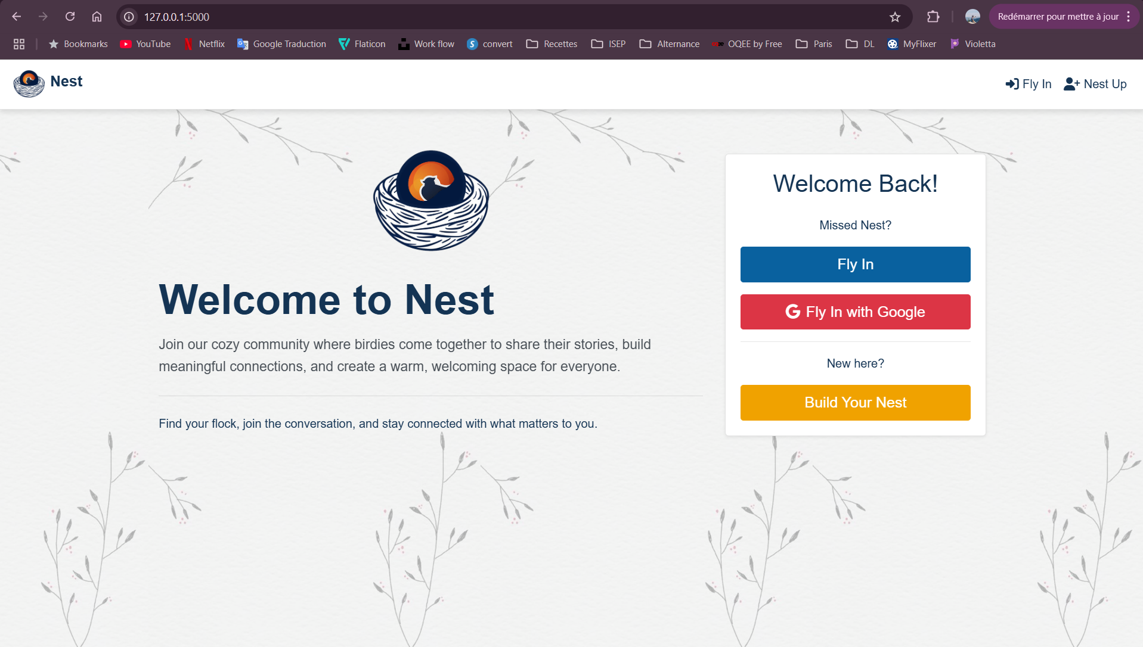

Scenario 2: Friend Connection & Recommendation
- User adds a friend.
- Backend updates graph-based data structure.
- Recommendation engine suggests new friends based on mutual connections.
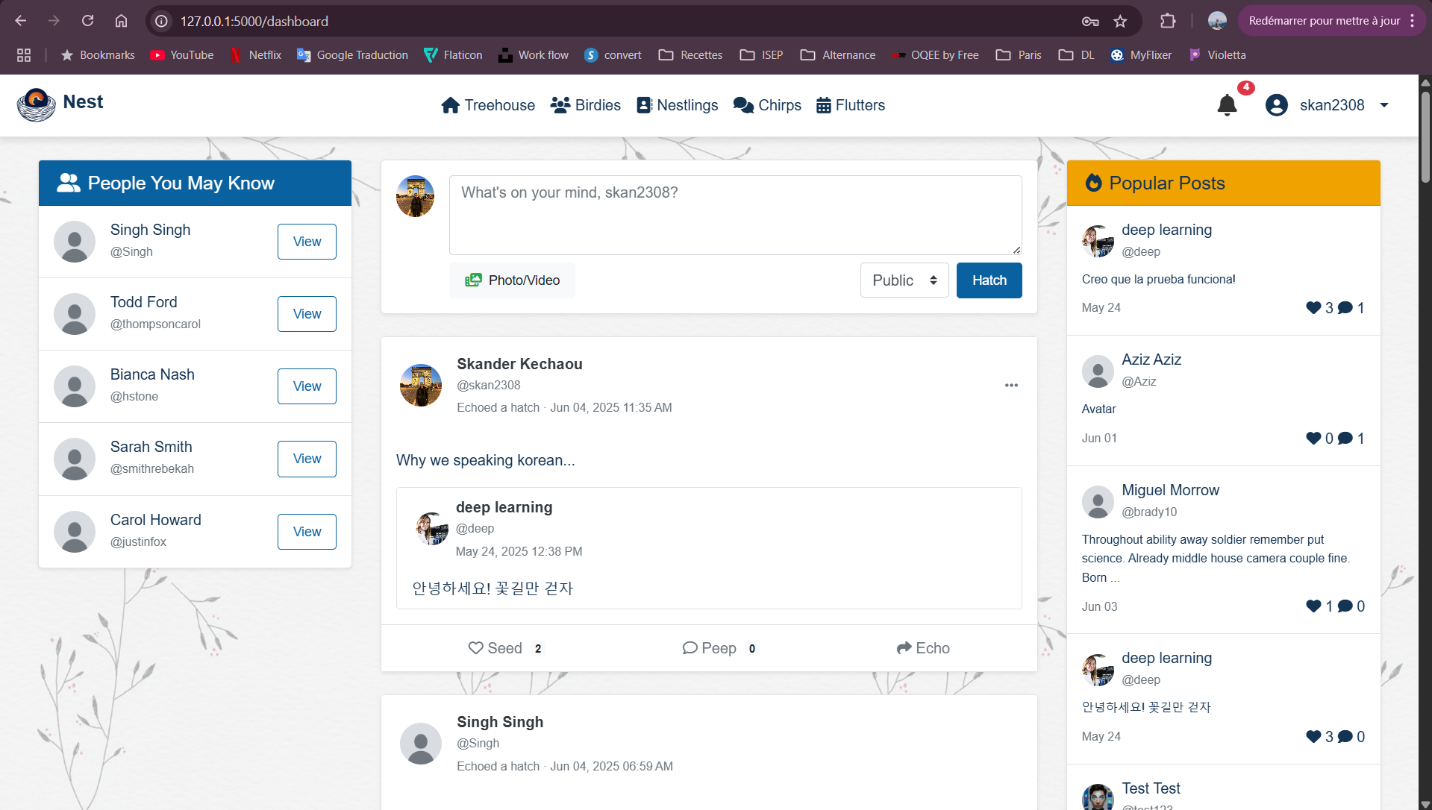

Scenario 3: Content Sharing & Feed
- User posts an image with a caption.
- Friends see the post in their personalized feed.
- Likes and comments are enabled in real-time.
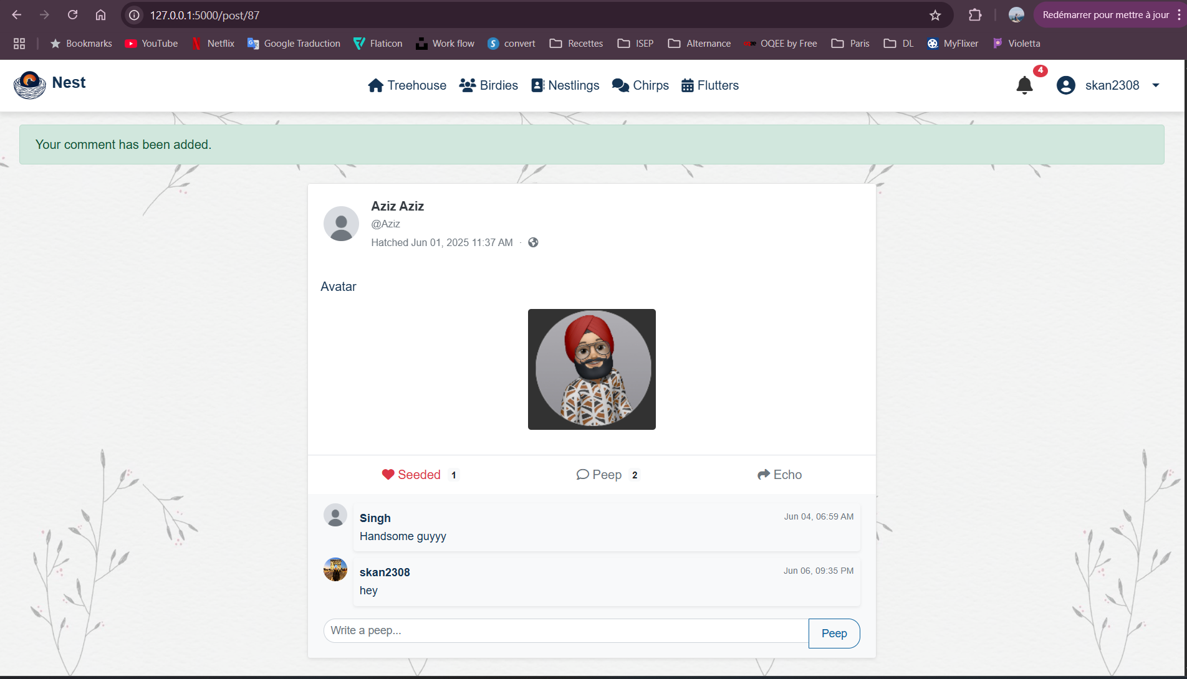

Scenario 4: Real-Time Messaging
- User opens chat window with a friend.
- Messages sent/received instantly using Flask-SocketIO.
- Notifications alert the user of new messages.

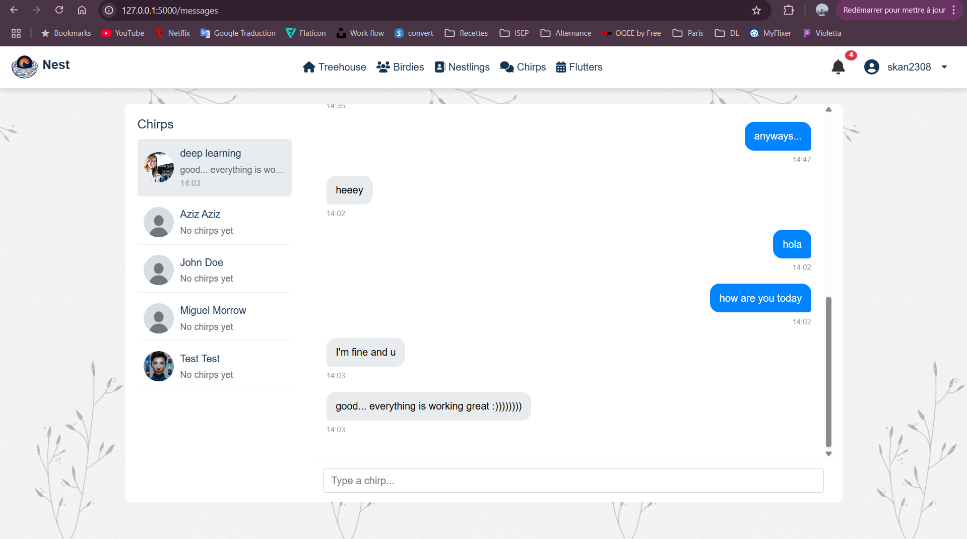

Scenario 5: Profile Customization
- User customizes their profile with biography, localisation and profile picture
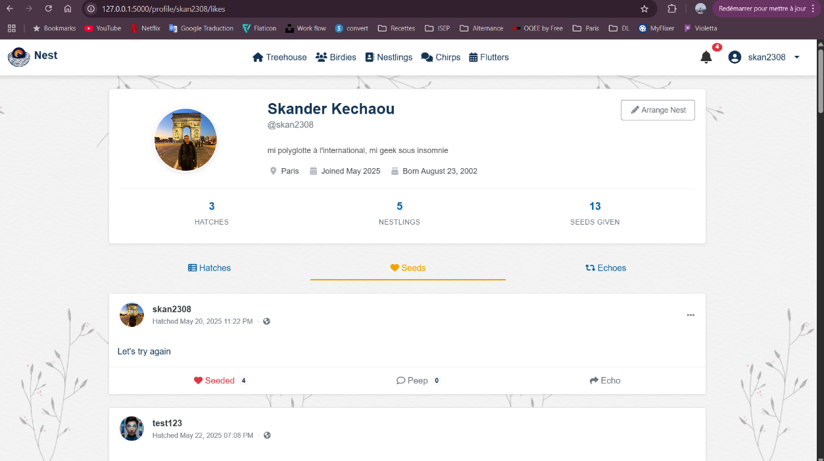
- User can check their own posts, comments, shares and social statistics

Scenario 6: Event
- User creates event, adds collaborator and participants can RSVP

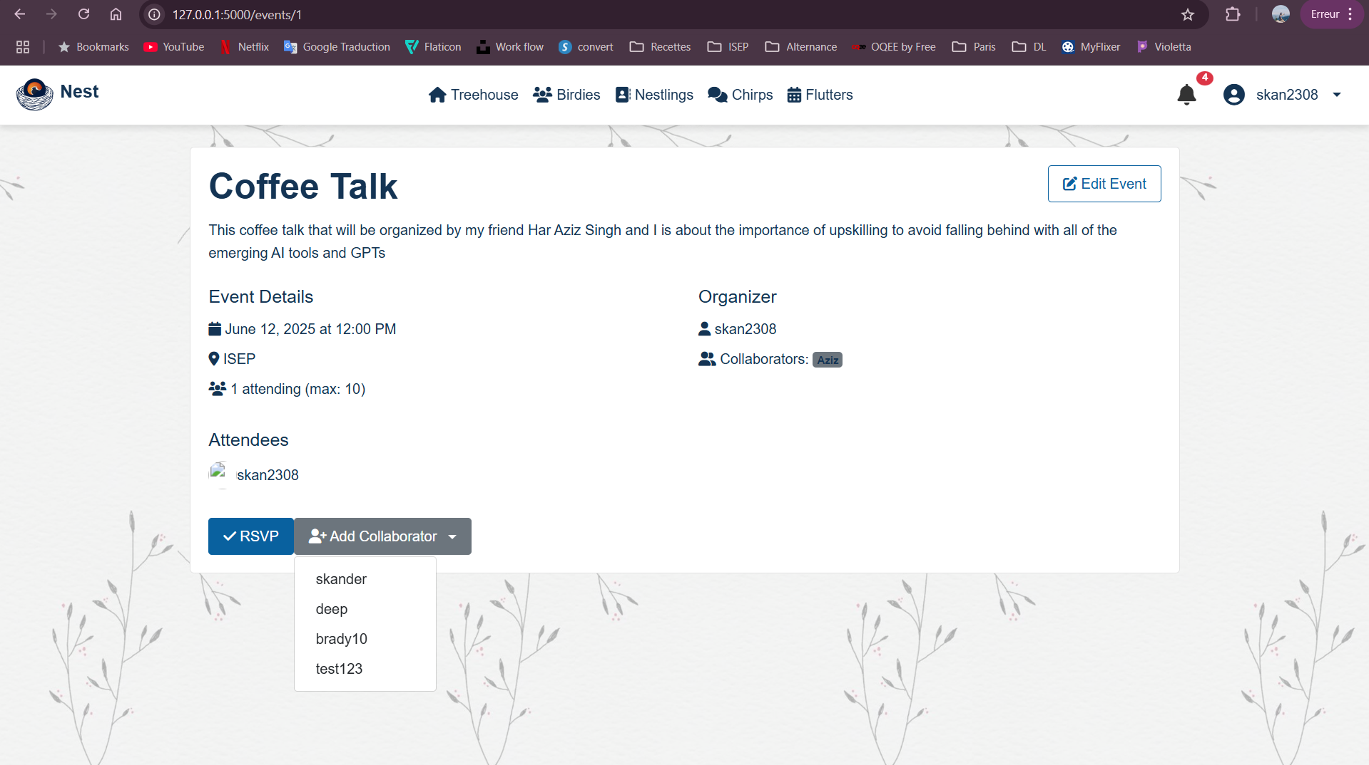

Scenario 7: Admin Dashboard
- Admin can connect and access the Dashboard
- Admin can manage users by activating, deactivating
- Admin can check statistics

